Escape Room Adventure

Design Document by Jake Morgenstern

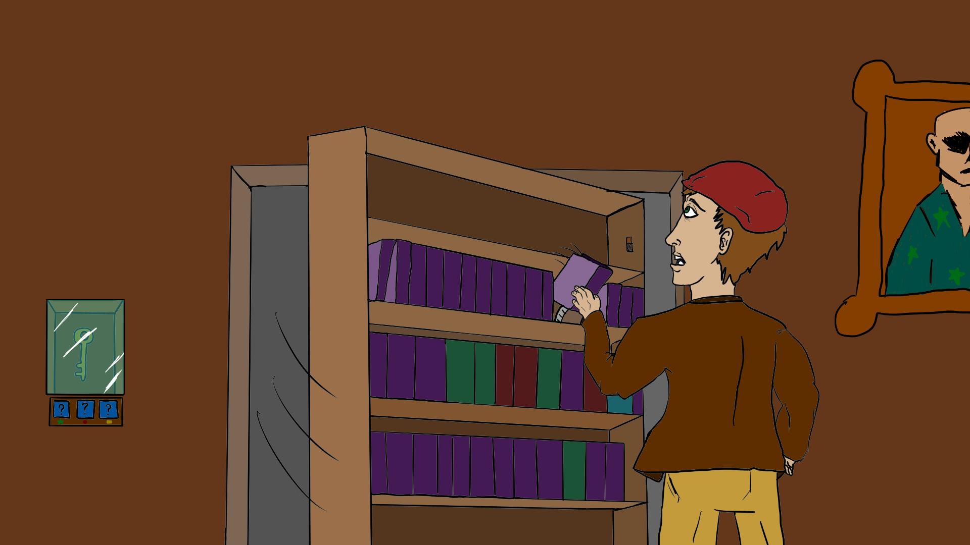

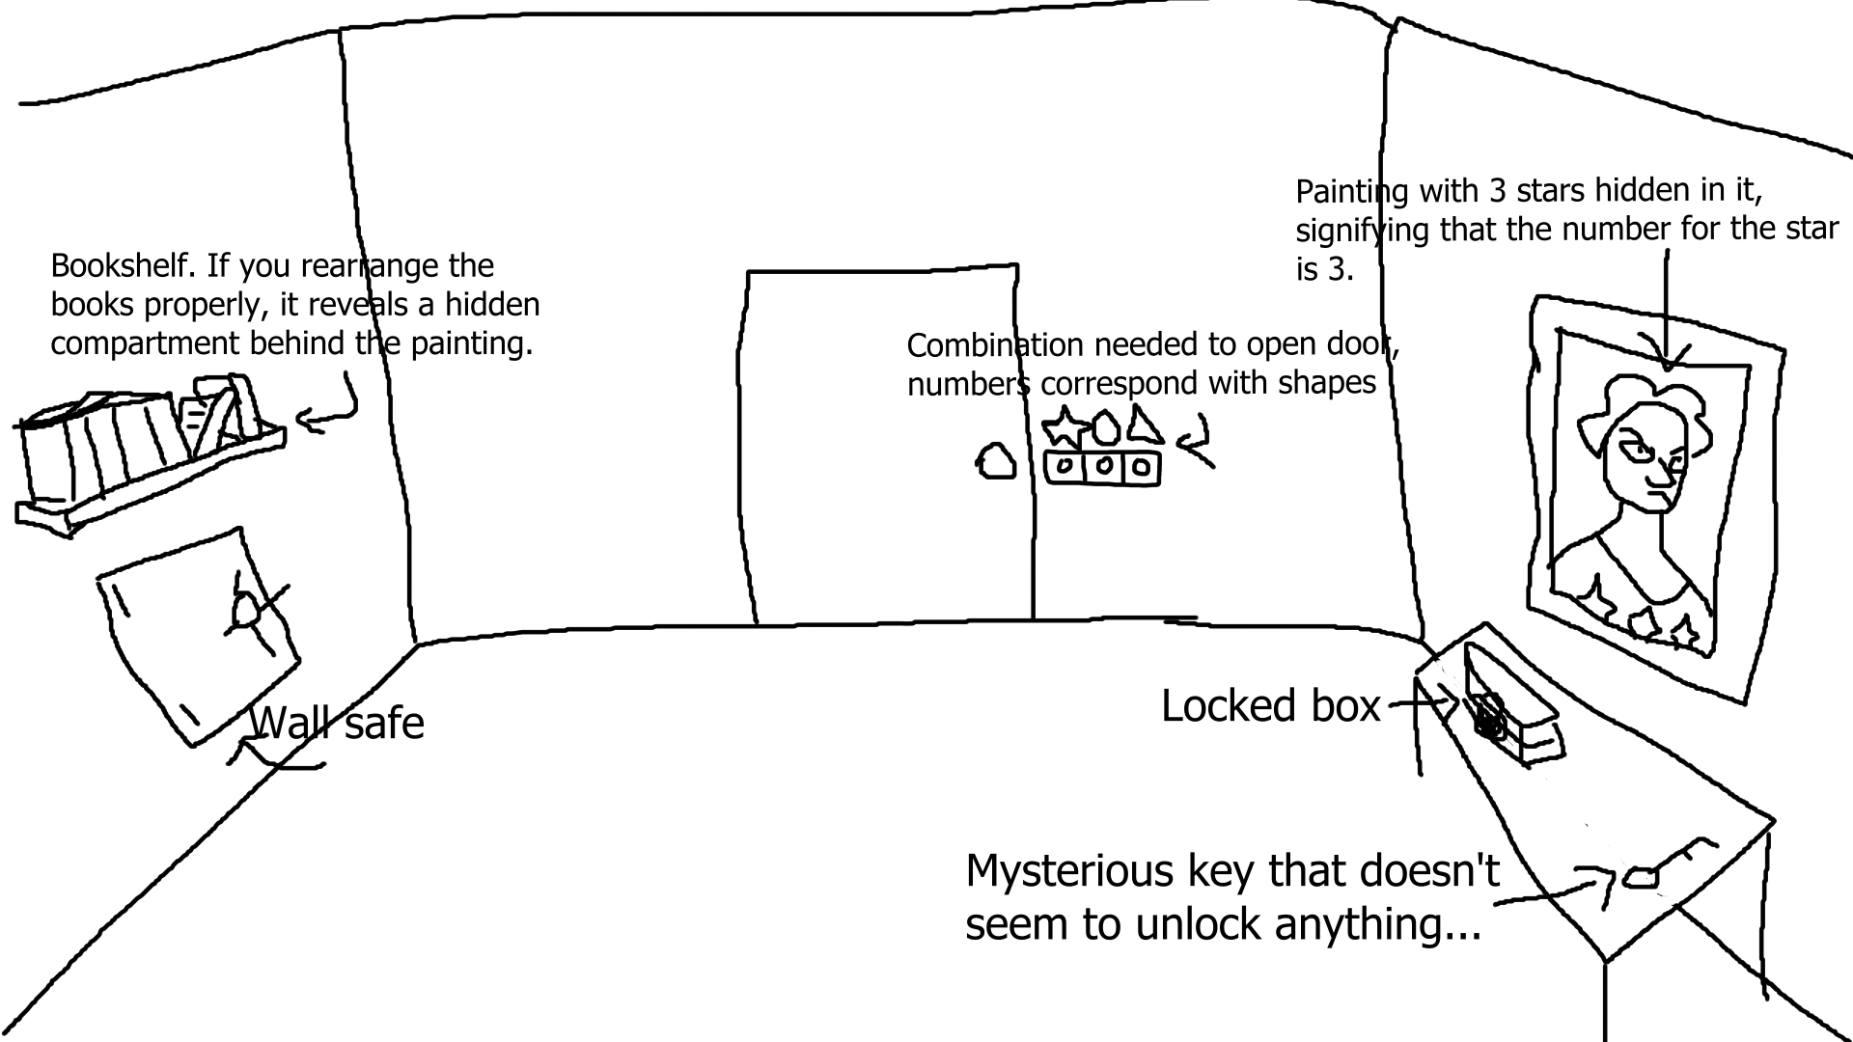

Introduction

Escape Room Adventure is a first person puzzle adventure game where players must solve intricate puzzles and follow cryptic clues to escape a series of mysterious rooms before time runs out, trapping them forever...

Gameplay

Players can walk around the room to observe their surroundings, click on important objects to inspect them up close, and interact with objects to perform various actions. For instance, a player might click to collect a key, then click on the corresponding door to use that key. Using items to solve puzzles will reveal more items and more puzzles, until the player finally has what they need to escape each room. Clues may be hidden in the environment or on/inside objects, so the player will have to inspect everything to find the answer! While they do this, a timer will count down to their demise, so they’ll need to escape the room before that happens.

Look and Feel

The final game will have a semi-realistic art style, and it will use medium-poly models for simplicity without being too cartoonish. Audio cues will denote when a player has solved a puzzle, unlocked a door, done something right in general, etc.

Goals

The goal for the prototype is a single room with at least 5 puzzles to escape, which should be completed in about 5 minutes, but the time limit can be changed based on testing. Putting in a simple character controller and interaction with items to add them to the inventory is pretty easy, so that will be the goal for the first week. Weeks 2 and 3 will be interacting with items that require other items to do something (like using a key to open a door), and the final week will be putting it all together to make 5 puzzles. More puzzles or more types of interactables can be added as time permits.

Resources Needed:

Models and art for an escape room, including tables, shelves, keys, paintings, boxes, locks, doors, etc.

Immersive ambient music and sound effects that fit a mystery setting, but will not distract the player from the puzzle they are trying to solve.

SWOT Analysis

| **Strengths:**  I’m a very strong programmer already, and I’ve already done things like a first person character controller, interacting with items by clicking, etc. before, so it should be simple to implement them and then move on to the new stuff. | **Weaknesses:**  I have two other game development projects going on currently, so splitting my time between 3 projects is going to be rough. |
| --- | --- |
| **Opportunities:**  Puzzle games are very popular, and people love escape rooms in real life, so this would allow them the same kind of experience without needing to leave their home. | **Threats:**  There are several similar games on Steam already. |

**Works Cited**

All models I used were created by me

The sound effects are from <https://pixabay.com/sound-effects/>

I also used this sound pack from <https://kenney.nl/assets/ui-audio>

The custom editor attribute I used is from <http://answers.unity.com/answers/793967/view.html>

I used the Open Sans font from Google: <https://fonts.google.com/specimen/Open+Sans>

I used the A Dripping Marker font by Wick van den Belt: <https://www.dafont.com/a-dripping-marker.font>

I used LeanTween for simple code-based animations: <https://assetstore.unity.com/packages/tools/animation/leantween-3595>

The outline shader I used is from <https://github.com/Robinseibold/Unity-URP-Outlines>

The grid layout component I used is from <https://www.youtube.com/watch?v=CGsEJToeXmA>